KIDS BIKES for sale

Package including a 12" Disney•Pixar Cars Boys’ Bike by Huffy & A Disney•Pixar Cars scotter ($25)

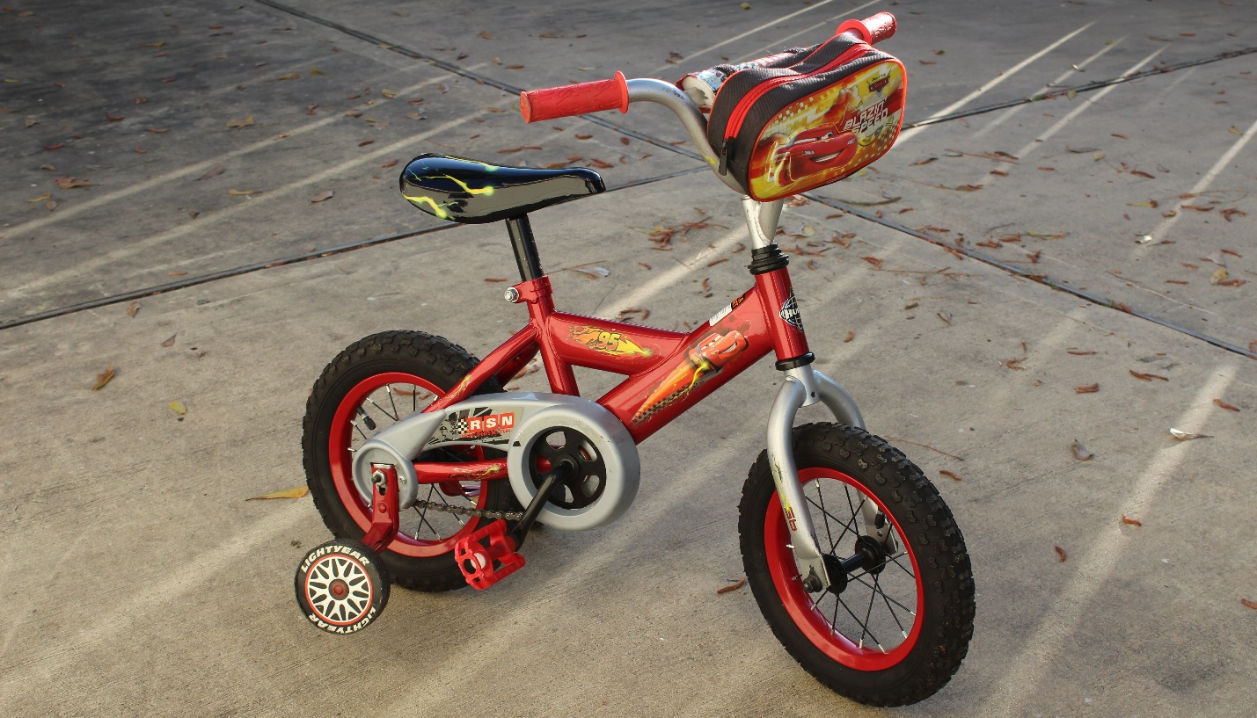
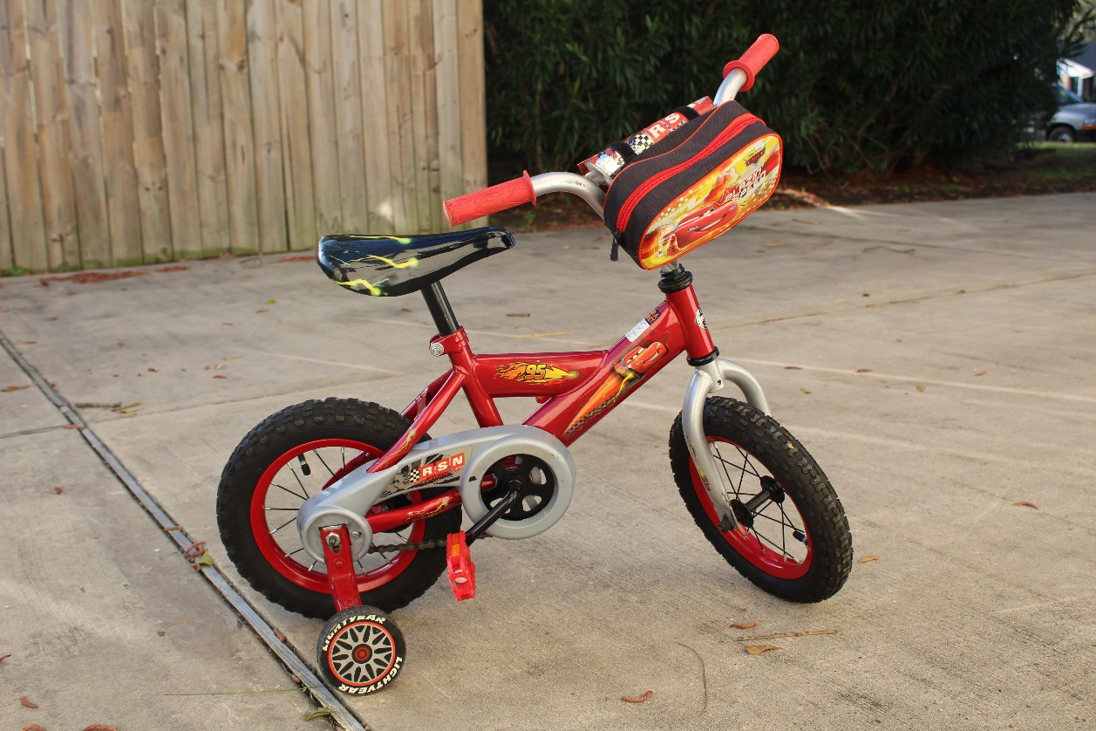
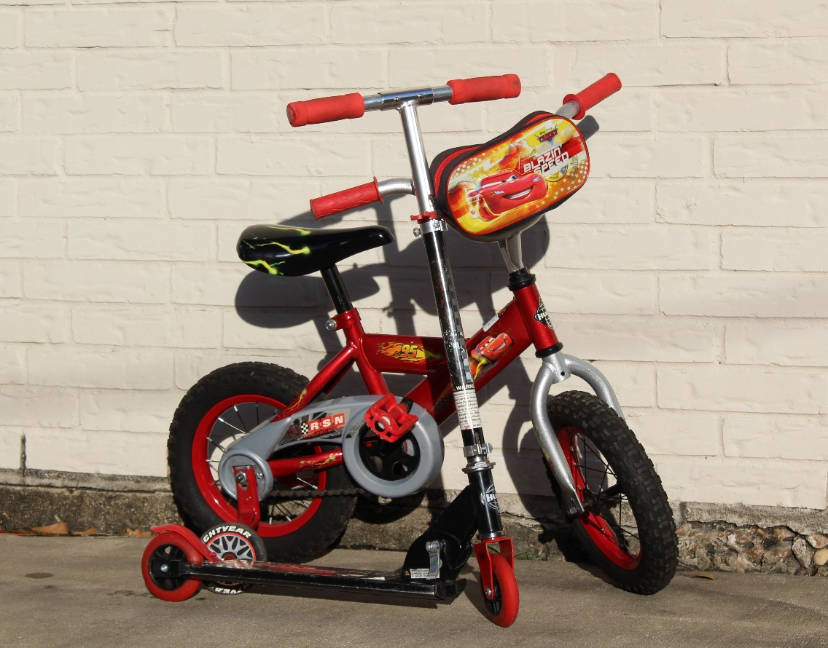

Similar item:

14" GIRL’s Bike by B’twin for 4/6 years old ($15)

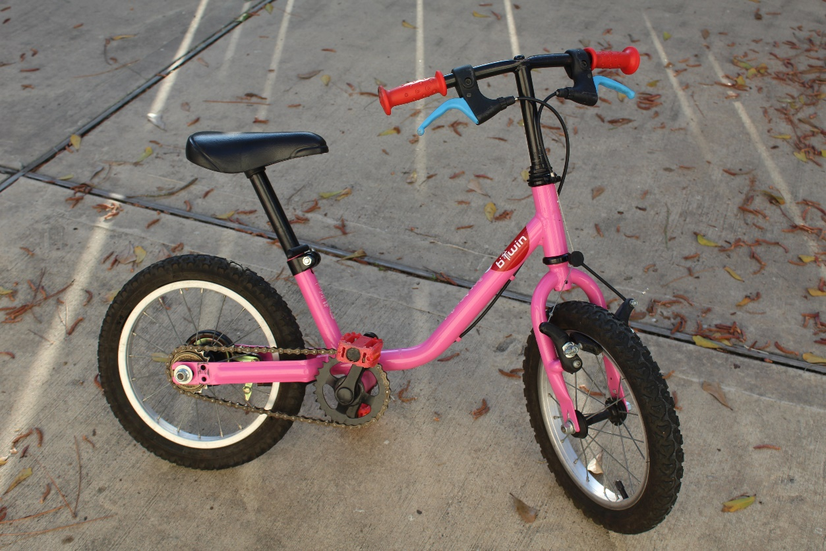

20" GIRLs’ Bike by B’twin for 6/8 years old ($40)
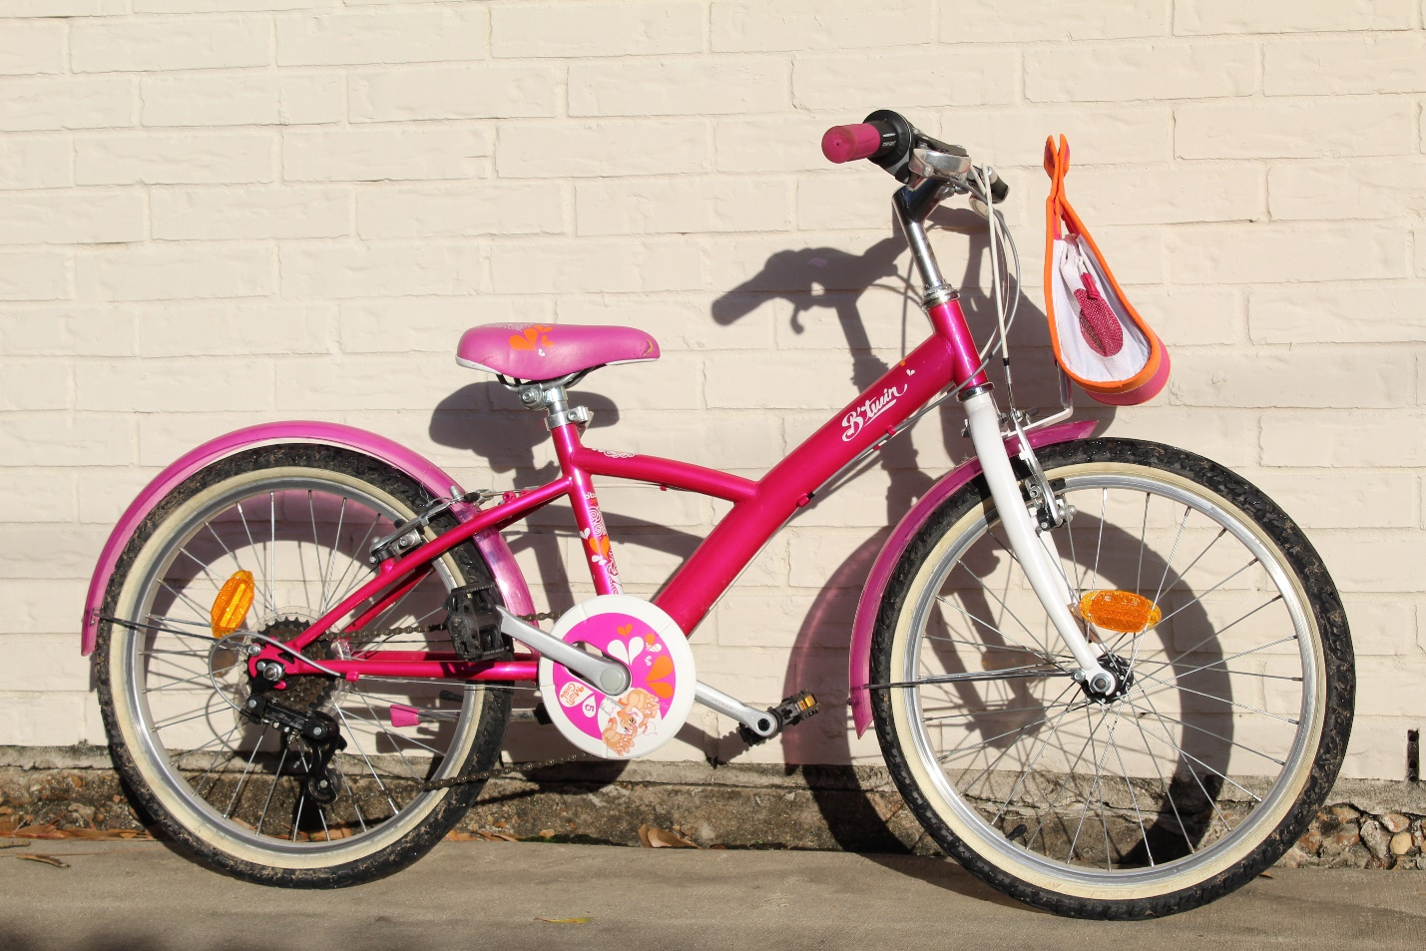
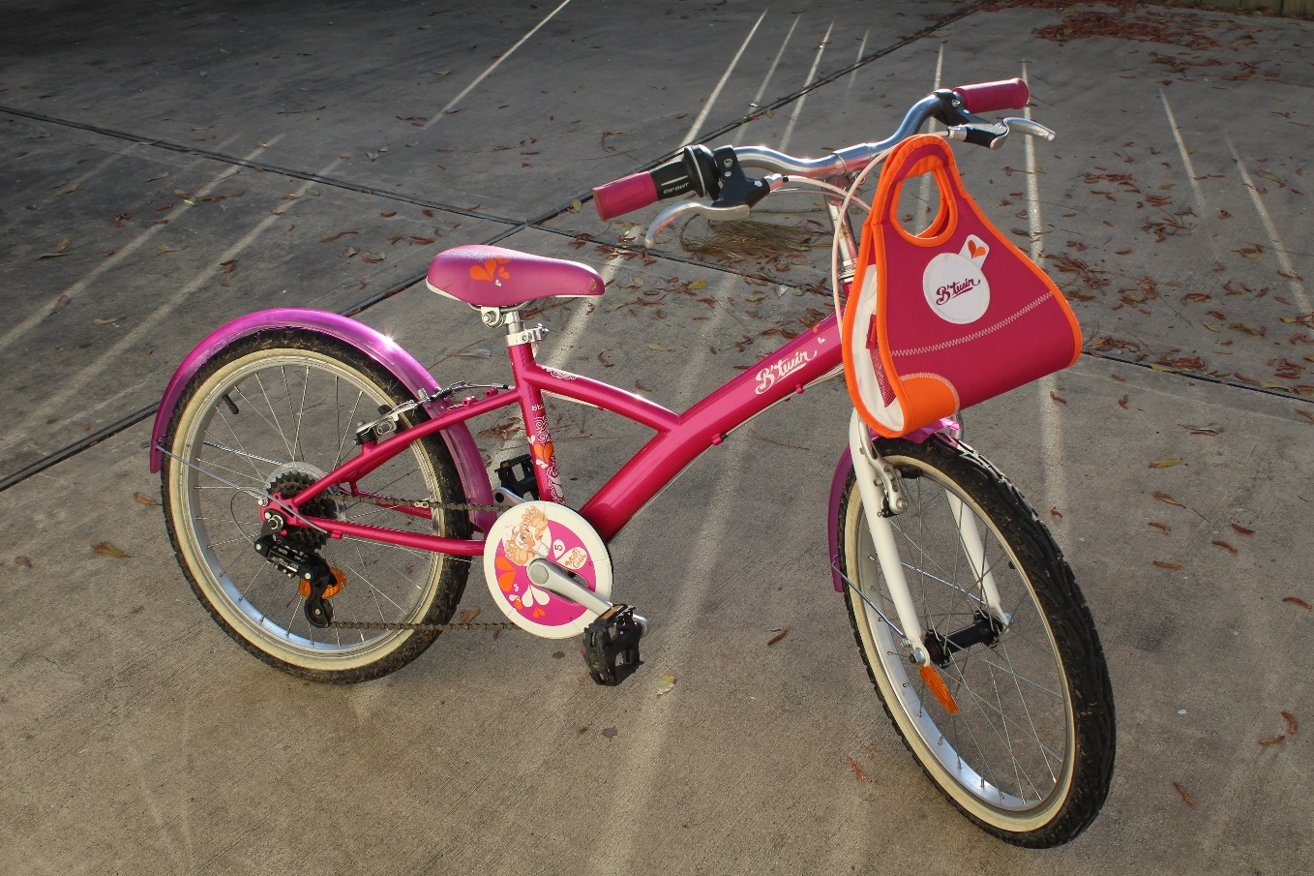

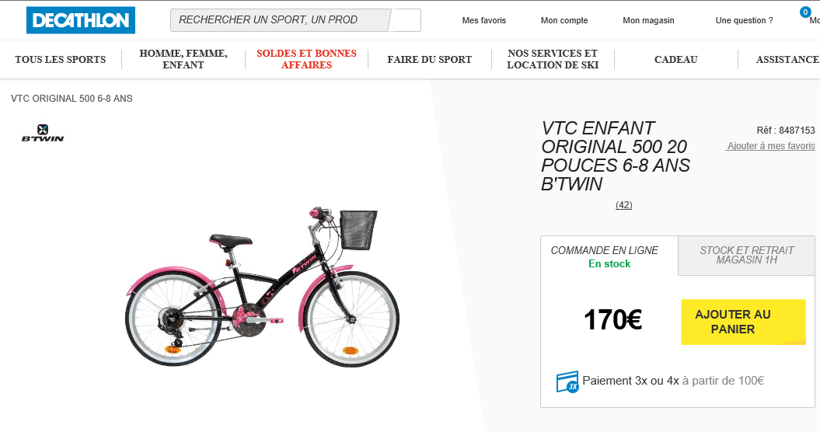

24" GIRLs’ Bike by Schwimm for 8/12 years old ($45)

