KIDS COSTUMES for sale

NASA Astronaut Suit with Cap – size 4/6 – Excellent condition ($25)
Aeromax Jr. Astronaut Suit with Embroidered Cap and NASA Patches – excellent condition
- AUTHENTIC LOOK and feel the part of a real NASA astronaut.
- INCLUDES: one astronaut suit with cap
- REALISTIC details including embroidered NASA patches, padded collar, high quality zippers, hook and loop straps at ankle, shoulder and waist harness straps and more…
- QUALITY CONSTRUCTION both inside and out. Machine washable, please wash inside out for best results. Use over and over again so your kids will outgrow this before they wear it out.

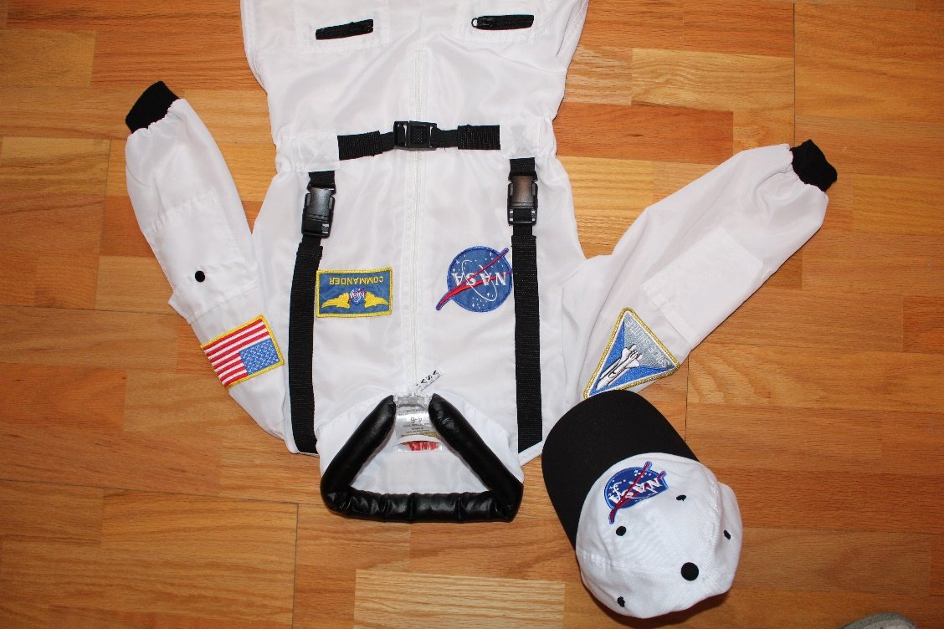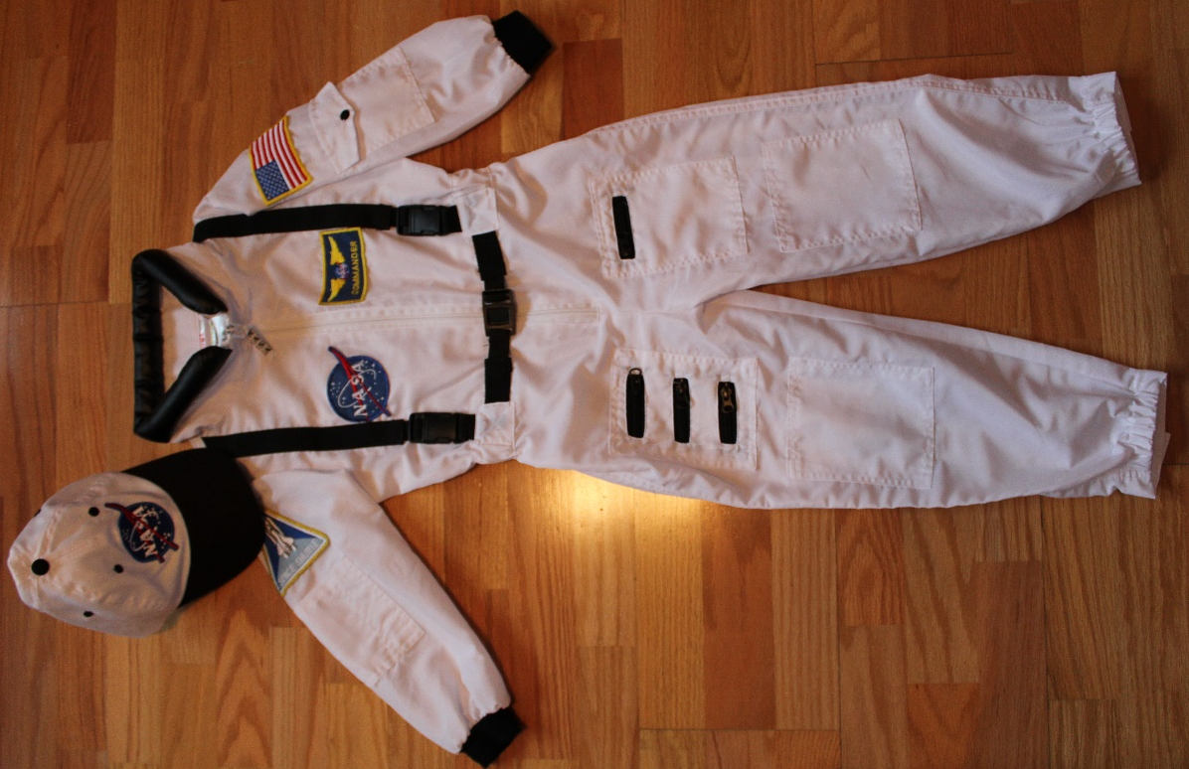

NINJA Deluxe Costume with Ninja throwing stars and 2 daggers – size 5/6 – Excellent condition ($15)
NINJA Deluxe Costume with Ninja 2 daggers and 3 throwing stars – EXCELLENT CONDITION
- includes Jumpsuit with Attached Hood, Face Mask, Belt, 3 Throwing Stars and 2 Ninja Daggers!!!
- Ninja Costume Kids Deluxe Costume Set. Super Durable. Superior Quality.
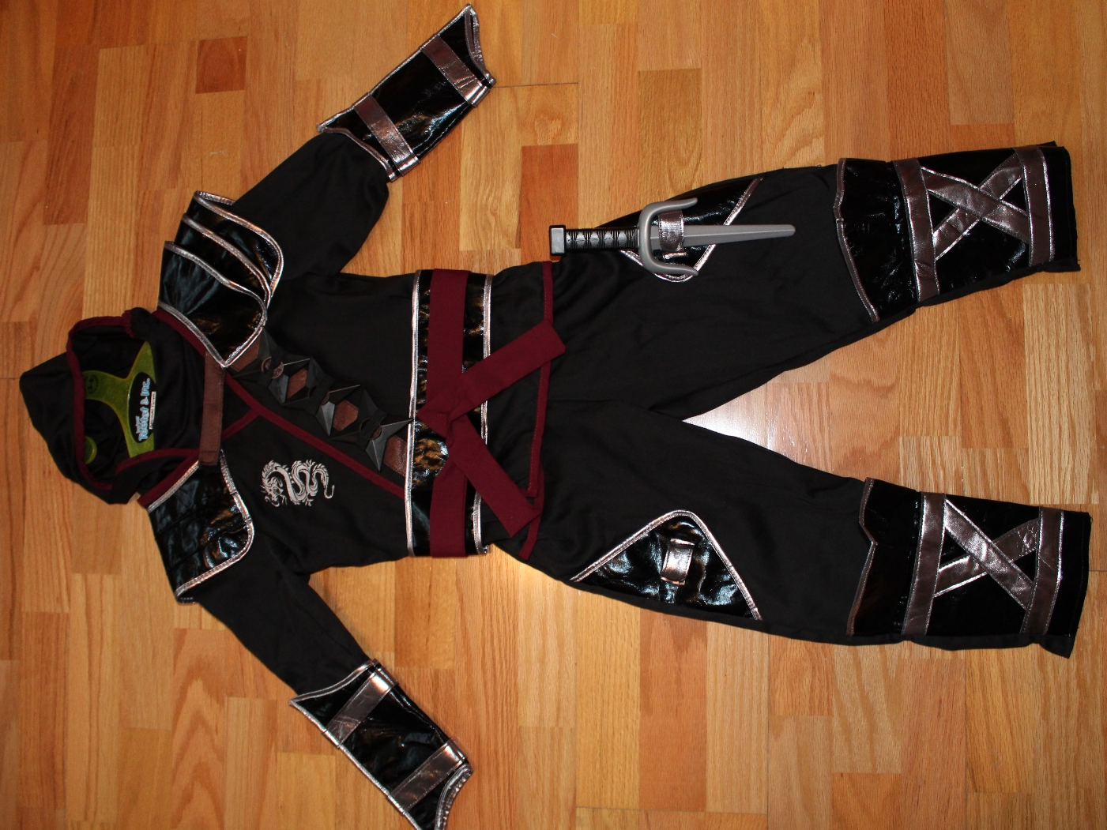

Package of Batman costume with CAPE and mask & Fireman jacket with Helmet and bullhorn – size 4/5 – good condition ($20)

- BATMAN Costume with abs Muscles, cape and mask – good CONDITION
- includes Jumpsuit with abs Muscles, Face Mask attached to the cape, and a Belt
- Size: 4/5 years old

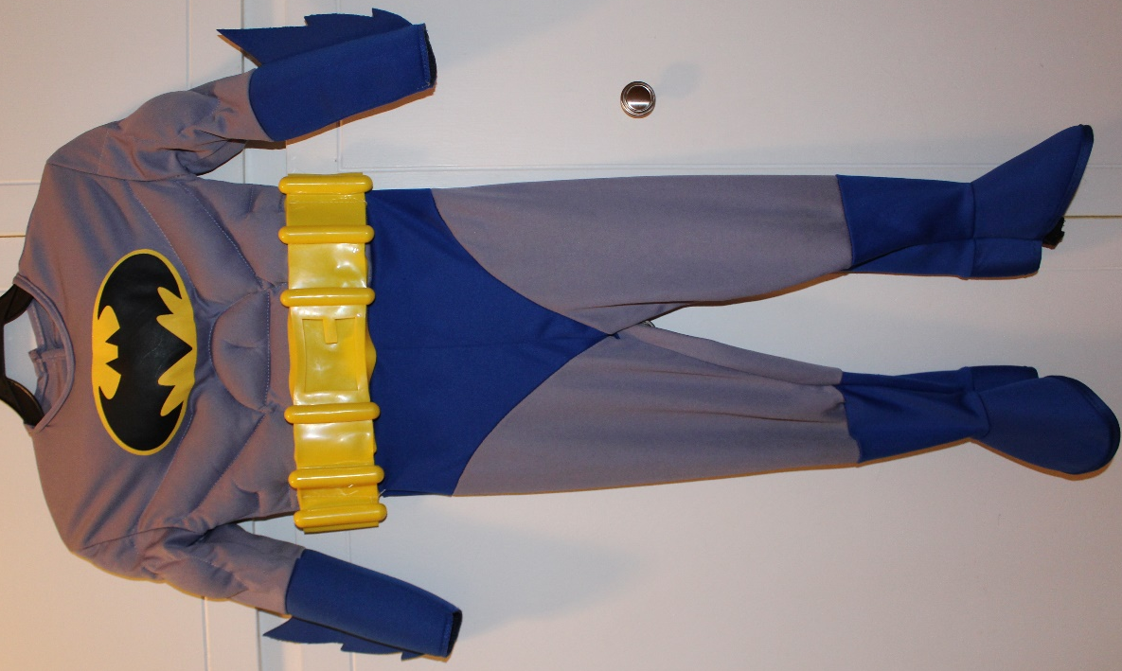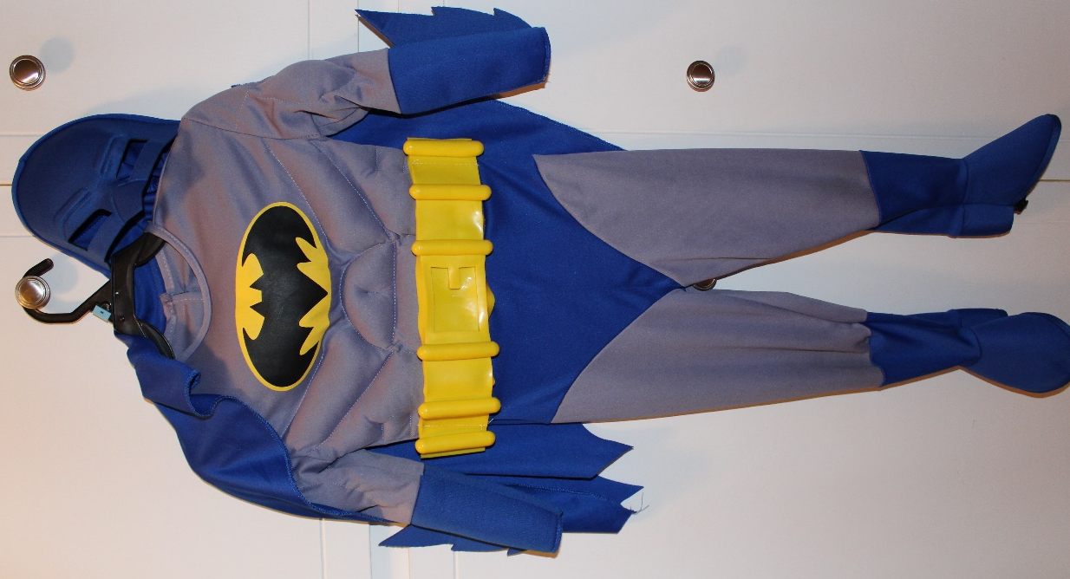

- Melissa & Doug Fire Chief Role Play Costume Dress-Up Set Costume – excellent condition
- Dress-up-and-play set with everything a child needs to look the Part, plus exciting accessories to Spur imaginative play
- Includes jacket, helmet, badge, bullhorn and reusable name tag.
- Bullhorn makes sound effects (batteries included)!
- High-quality materials ensure durability and safety.

