2019 LIVESTOCK Rodeo

cowboy boots & SHIRTS

RED COWBOY BOOTS – OLD WEST – Size 10.5 – Very good condition ($20)
- Red Cowboy boots – Old West – bought at Cavender’s
- Size 10.5
- Square toe
- Very good condition

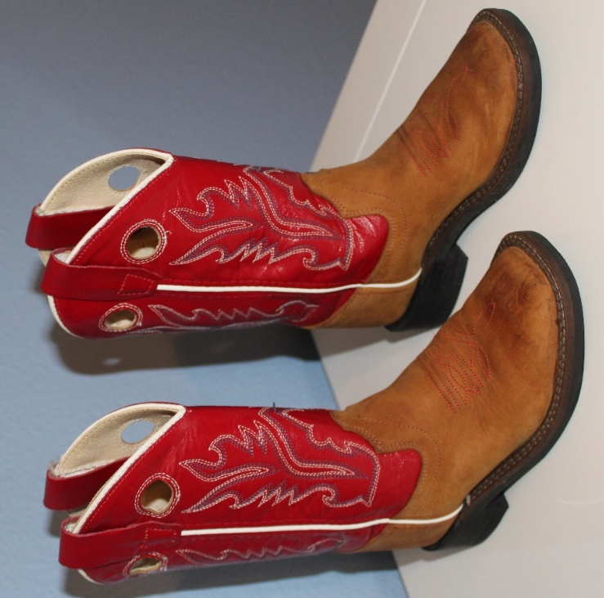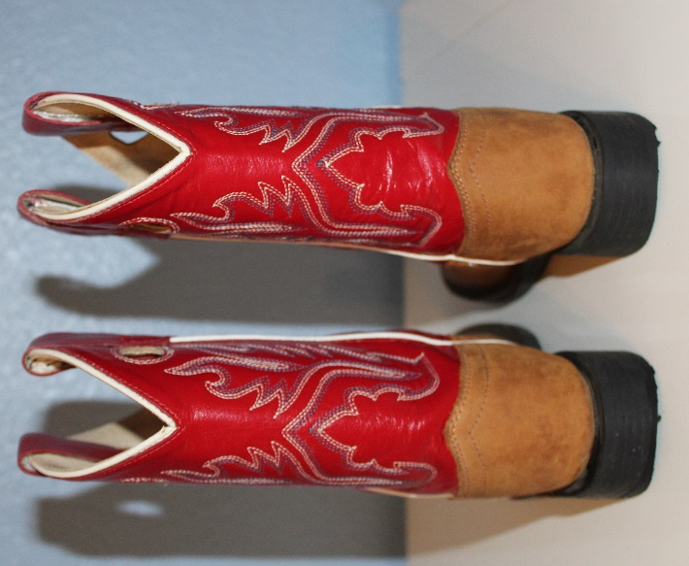

COWBOY SHIRTS – WRANGLER & Larry Mahan – Excellent condition ($25)

- Blue cowboy shirt – WRANGLER – originally bought at Cavender’s
- Long sleeves – size XS (3-4 years old)
- Excellent condition
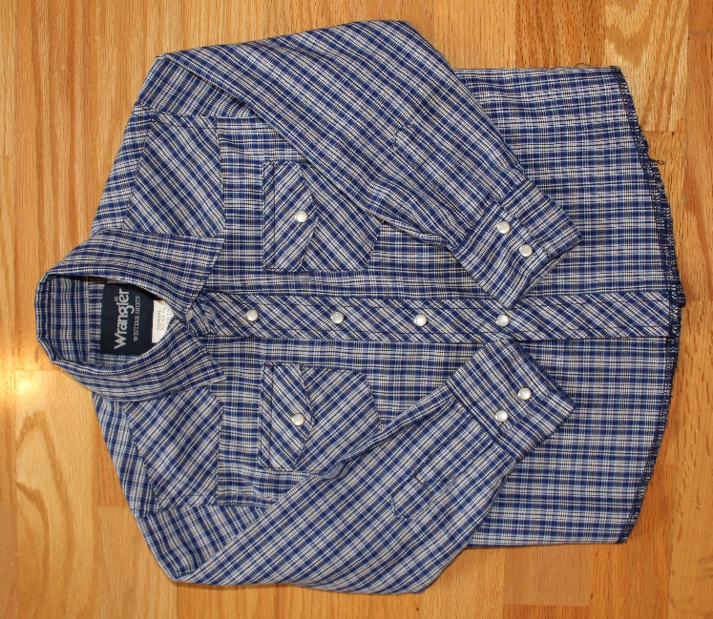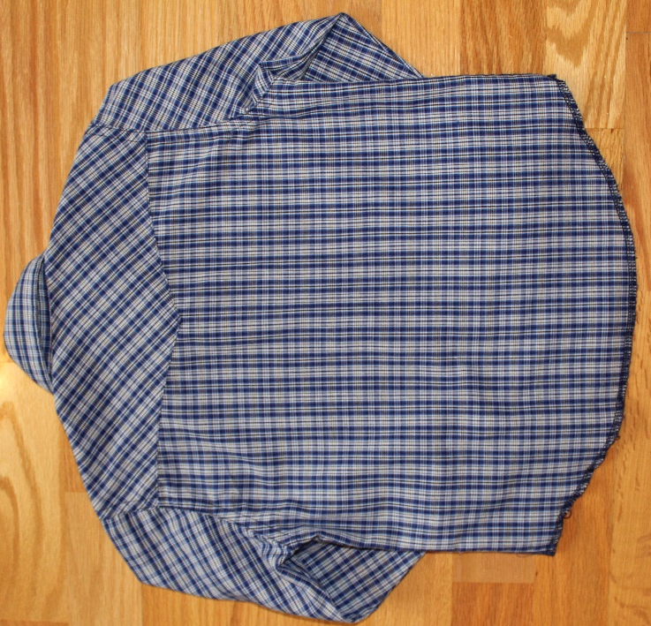

- Red cowboy shirt – LARRY MAHAN – originally bought at Cavender’s
- Long sleeves – size XS (2-4 years old)
- Excellent condition
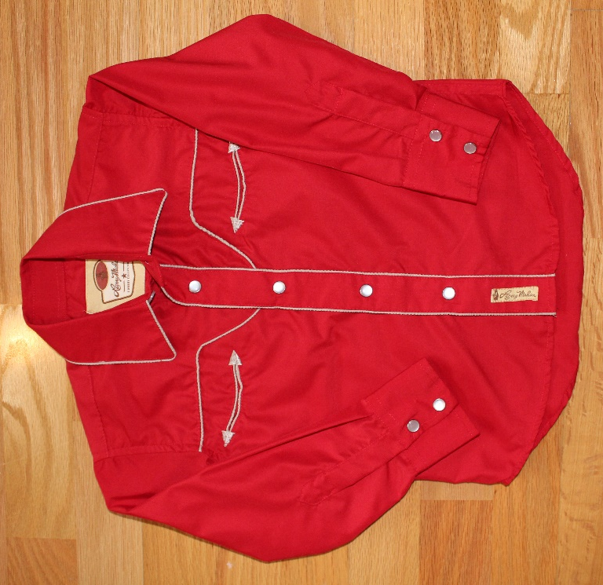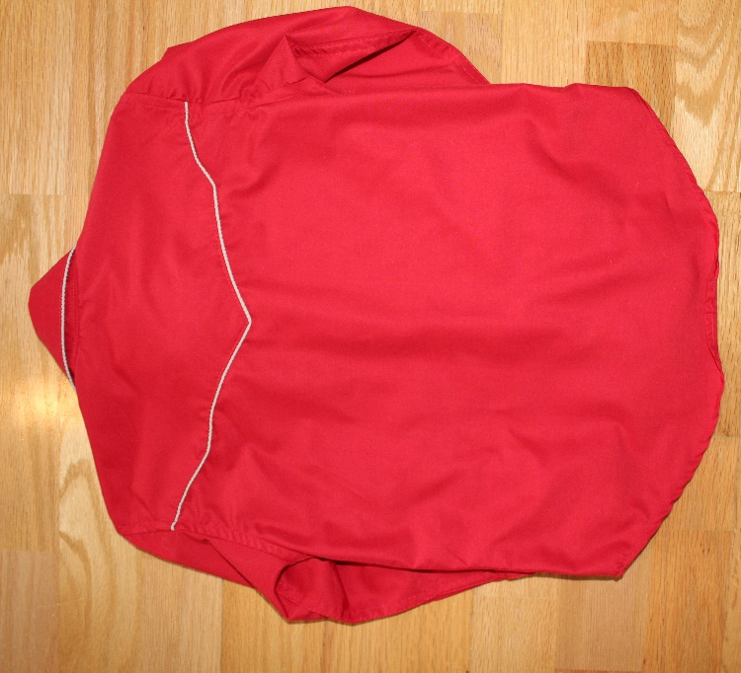

SparkY Blue COWgirl BOOTS – ROPER – Size 3 – Excellent condition ($30)
- Sparkly Blue Cowgirl boots – Roper – bought at Cavender’s
- Size 3
- Square toe
- Excellent condition
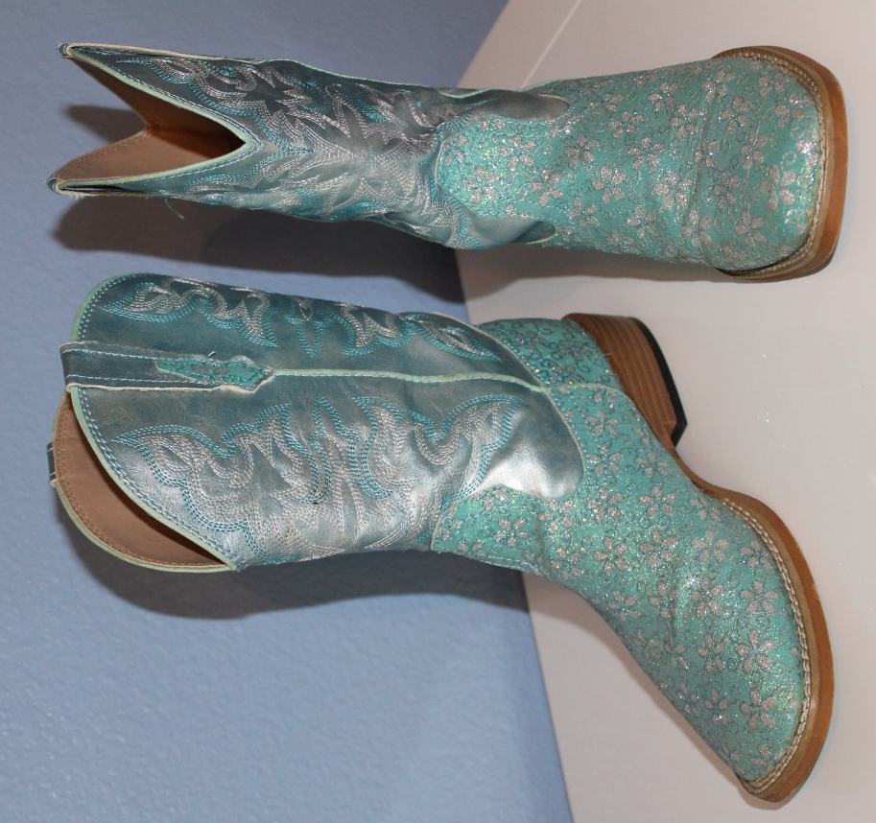

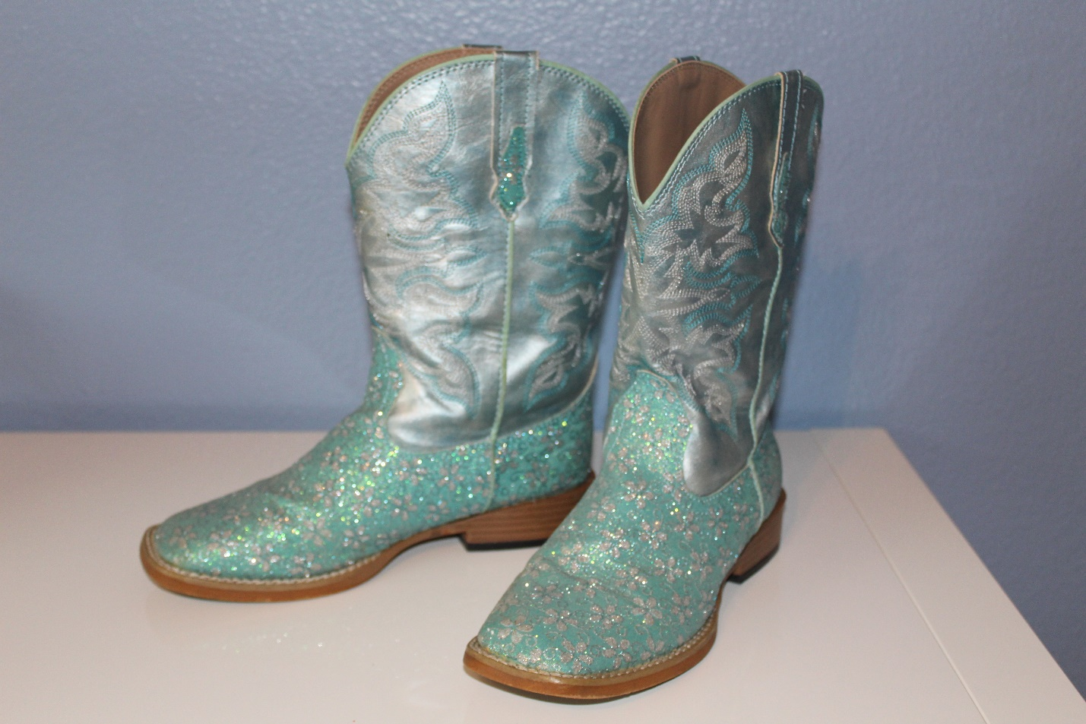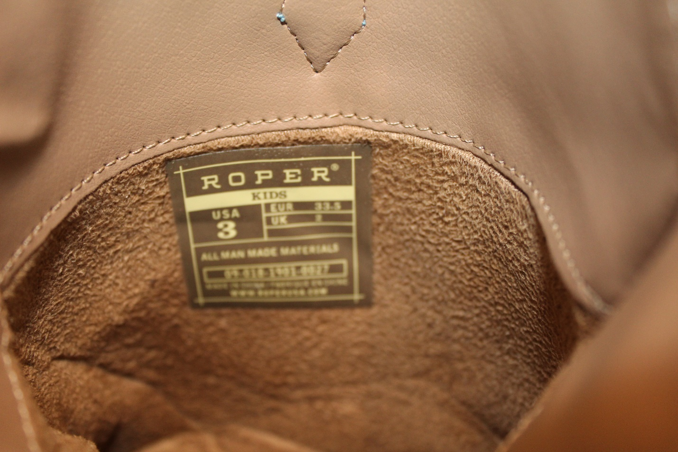

COWGIRL SHIRT – COWGIRL HARDWARE - Excellent condition ($18)

- Sparkly pink Cowgirl shirt – COWGIRL HARDWARE – bought at Cavender’s
- 100% cotton
- Long sleeves - Size M (8 -10 years old)
- Excellent condition

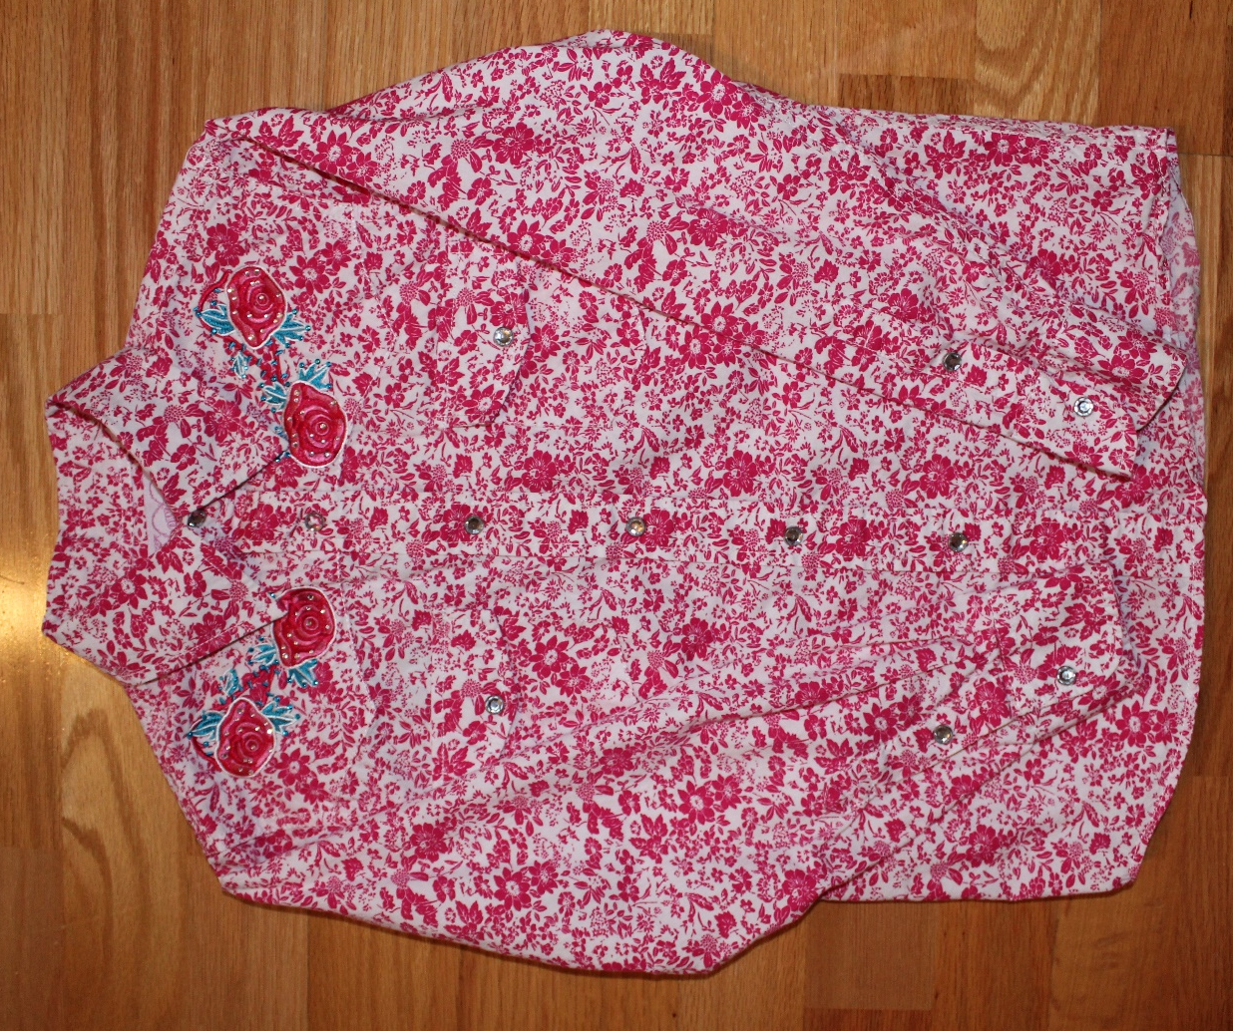

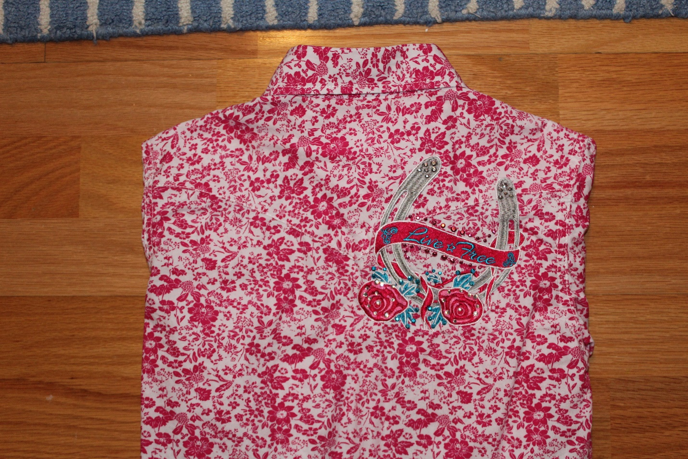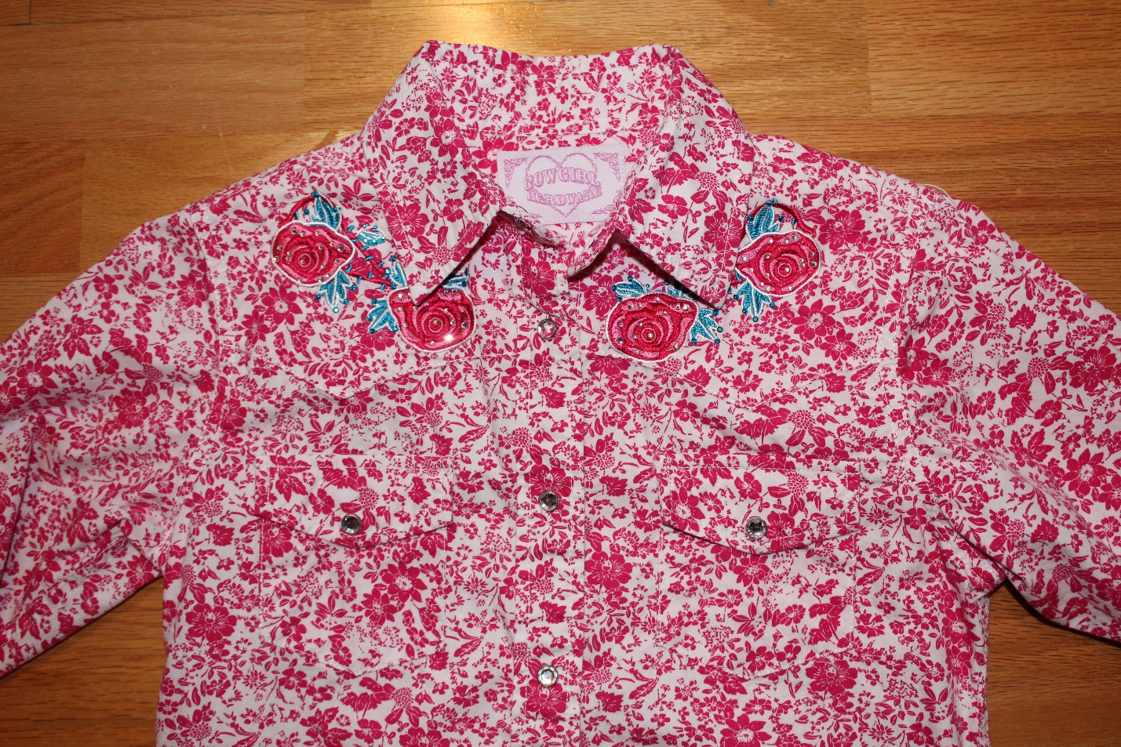

COWGIRL SHIRT – 09 Apparel - Excellent condition ($10)

- Pink Cowgirl shirt – 09 APPAREL - bought at Cavender’s
- Long sleeves – 6-8 years old
- Excellent condition

