Disney puzzles, My little Poney, princesses puzzles

nathan, MB Puzzles, DEJECO

Package of 2 puzzles & a wooden domino game : 101 Dalmatians + My little poney (4 years old) + Dora domino game (ALL items for $20)

- Disney puzzle “101 Dalmatians” – excellent condition – all pieces included (30 pieces)
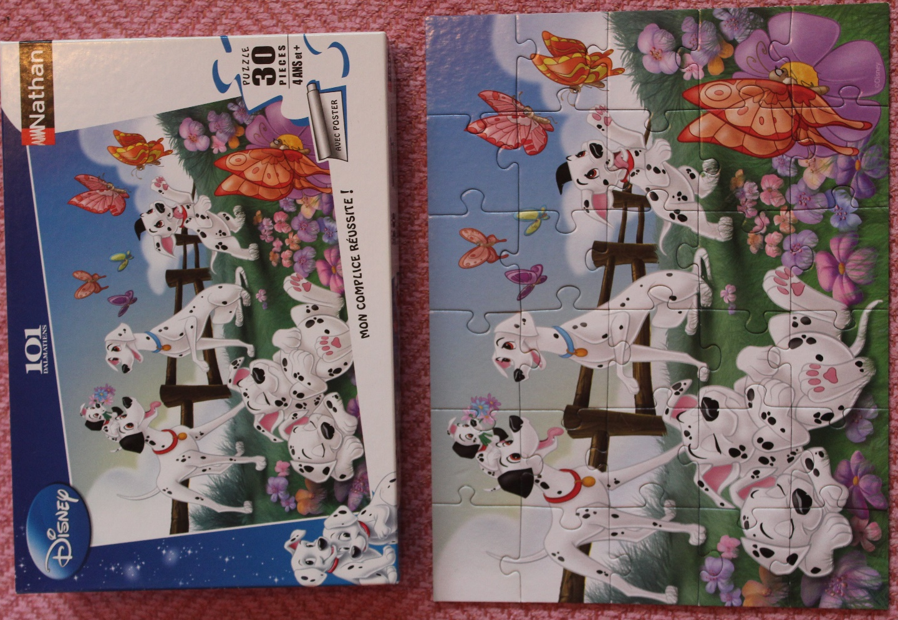
- MB Puzzles “My Little Poney” – 2 puzzles (35 pieces each) – excellent condition
- all pieces included
- recommended for kids 4+

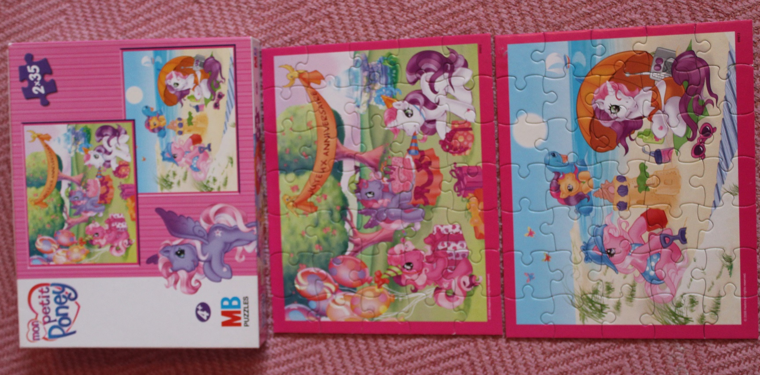
- Wooden domino game “DORA” – all pieces included - excellent condition
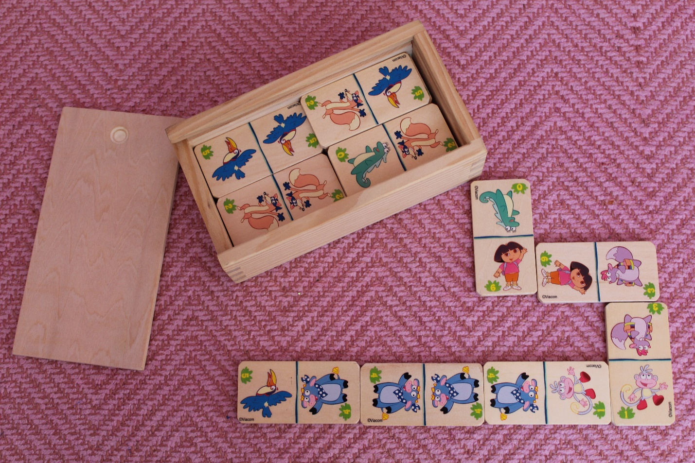

PrincEss Castle Puzzle – 4years old (Dejeco) - $14
Princess Castle (Dejeco) – high quality puzzle in excellent condition (36 pieces - all included)
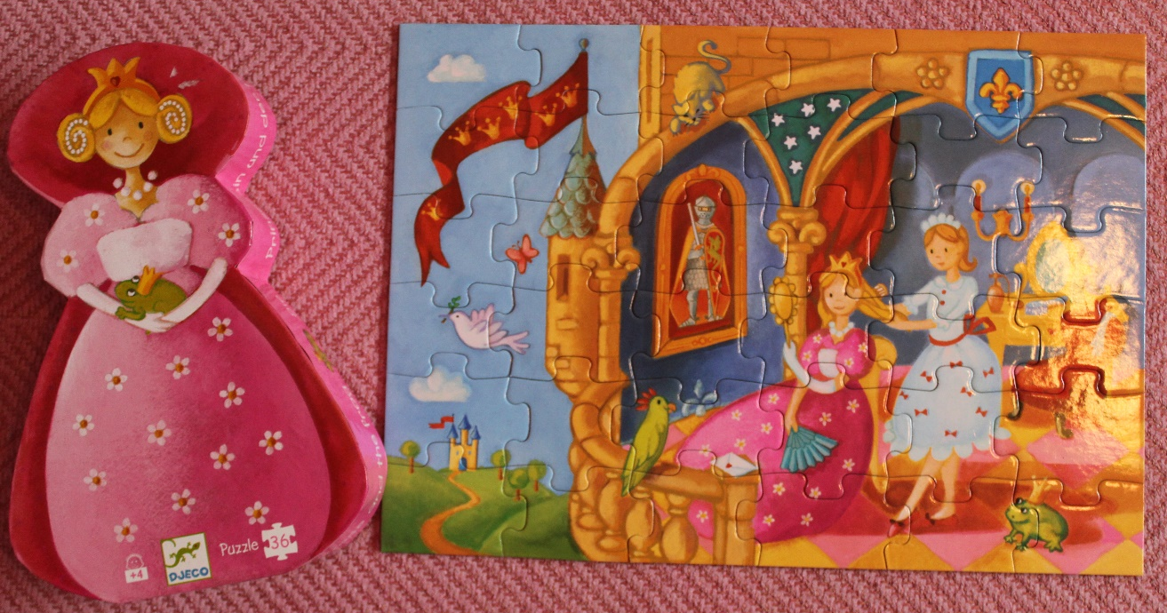
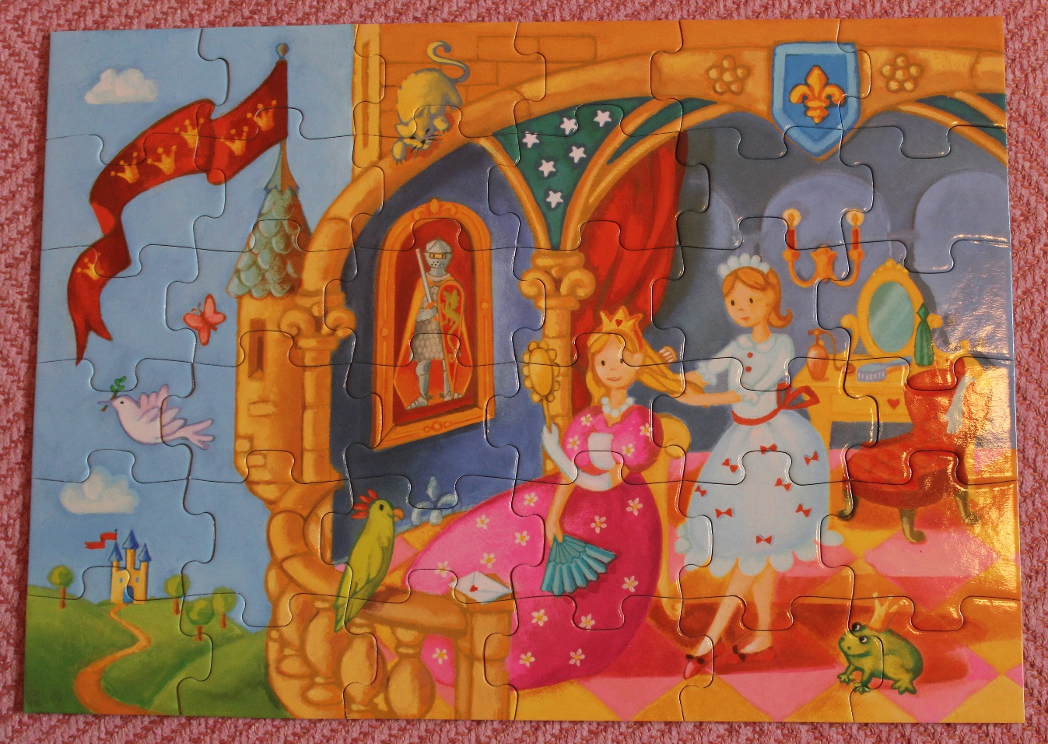

Package of 2 Disney puzzles (Nathan): Ariel + Disney Princesses (5 years old) -$15
- Ariel puzzle (Nathan) – excellent condition (45 pieces – all included)

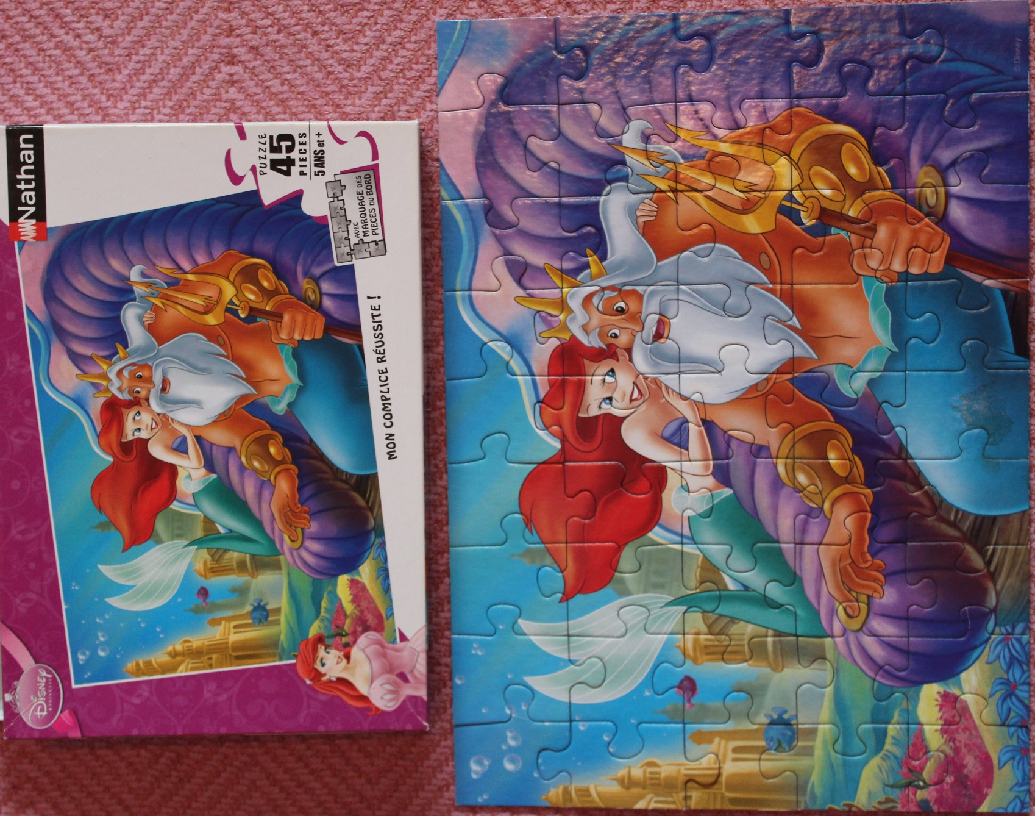

- Disney Princesses puzzle (Nathan) – excellent condition (45 pieces – all included)

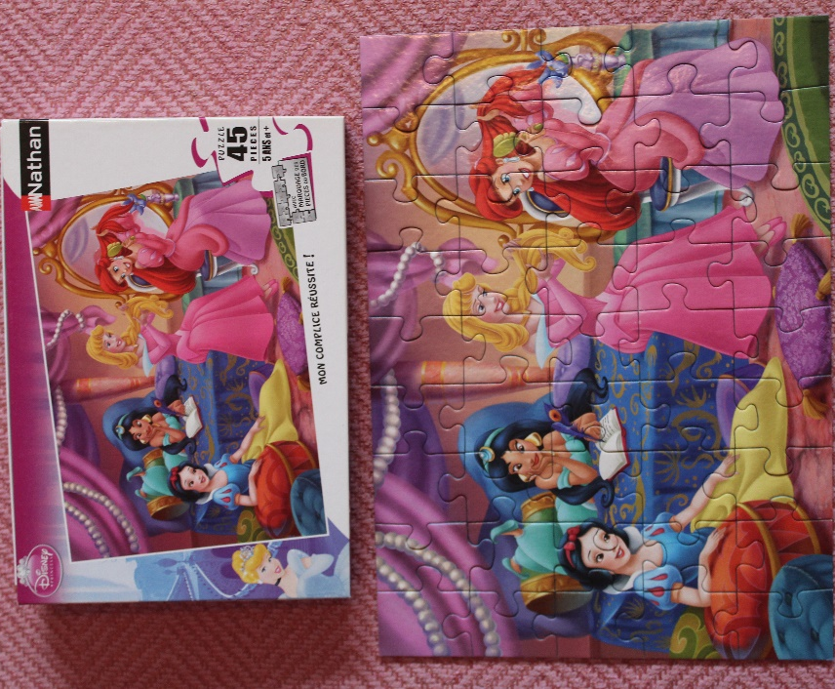

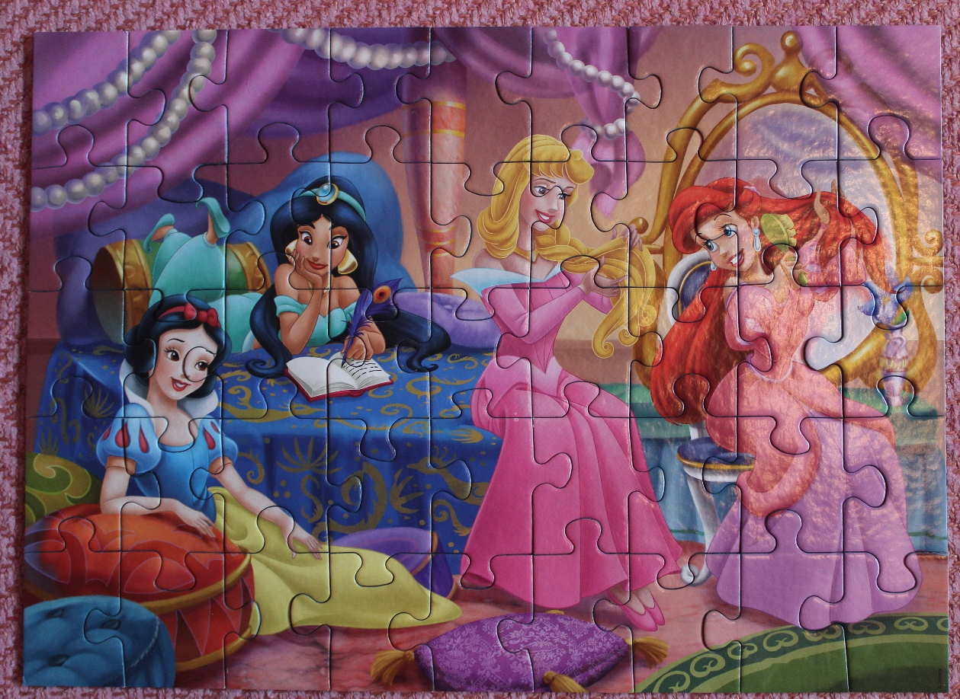

Package of 2 Disney puzzles (Nathan): Jasmine + Frozen (6 years old) - $18
- Jasmine & Aladdin puzzle (Nathan) – excellent condition (100 pieces – all included)

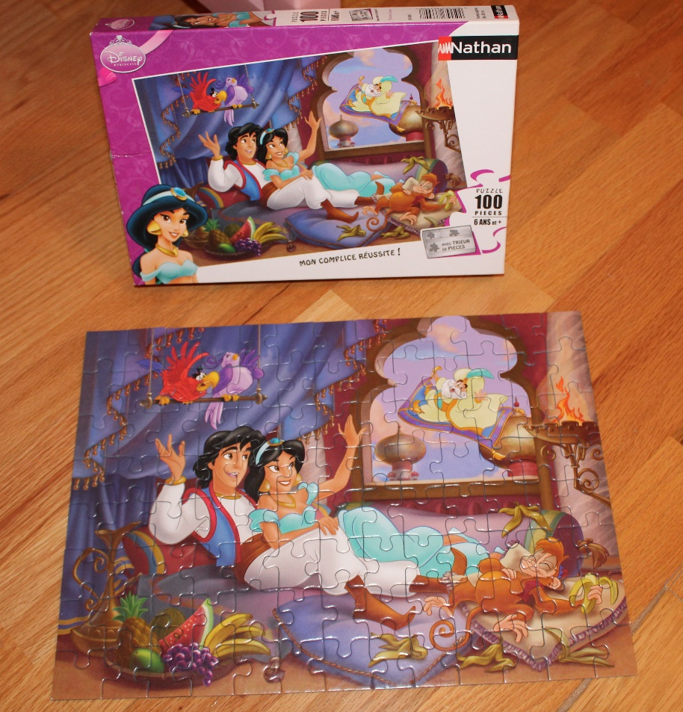

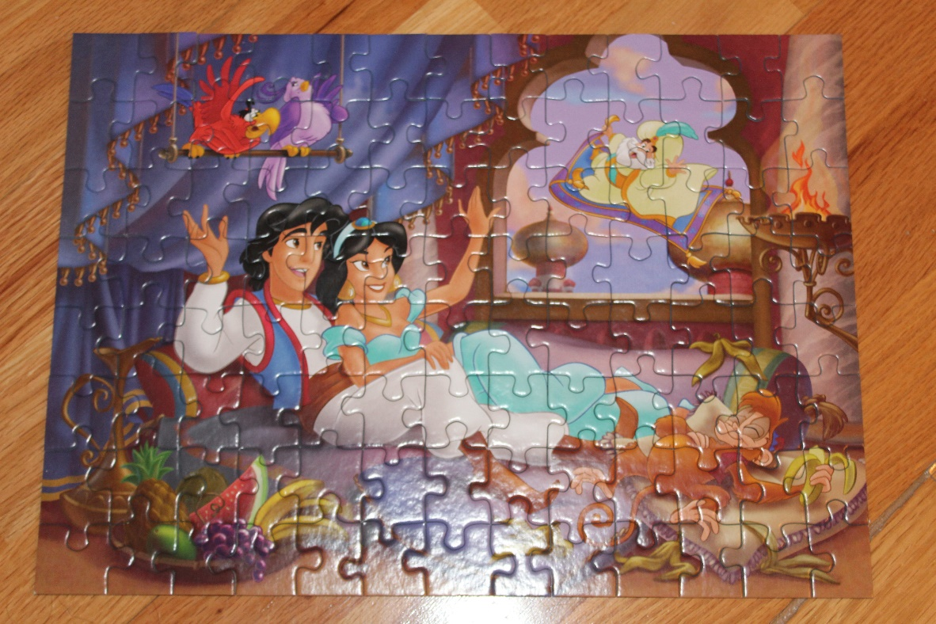
- Frozen puzzle (Ravensburger) – excellent condition (100 pieces – all included)

