HALLOWEEN KIDS COSTUMES

(Frozen, BATMAN, NINJA, Turbo racer, Fireman, etc…)

FROZEN Costume & handcraft articles – Size 8/10 – excellent condition ($15)
Beautiful blue satin inspired princess dress includes satin dress with lining and tulle, medallion pin, sequin bodice with attached sheer snowflake organza cape.
Frozen handcraft articles provided in addition to the costume. Your little one will enjoy building necklaces, wands and snowflakes.

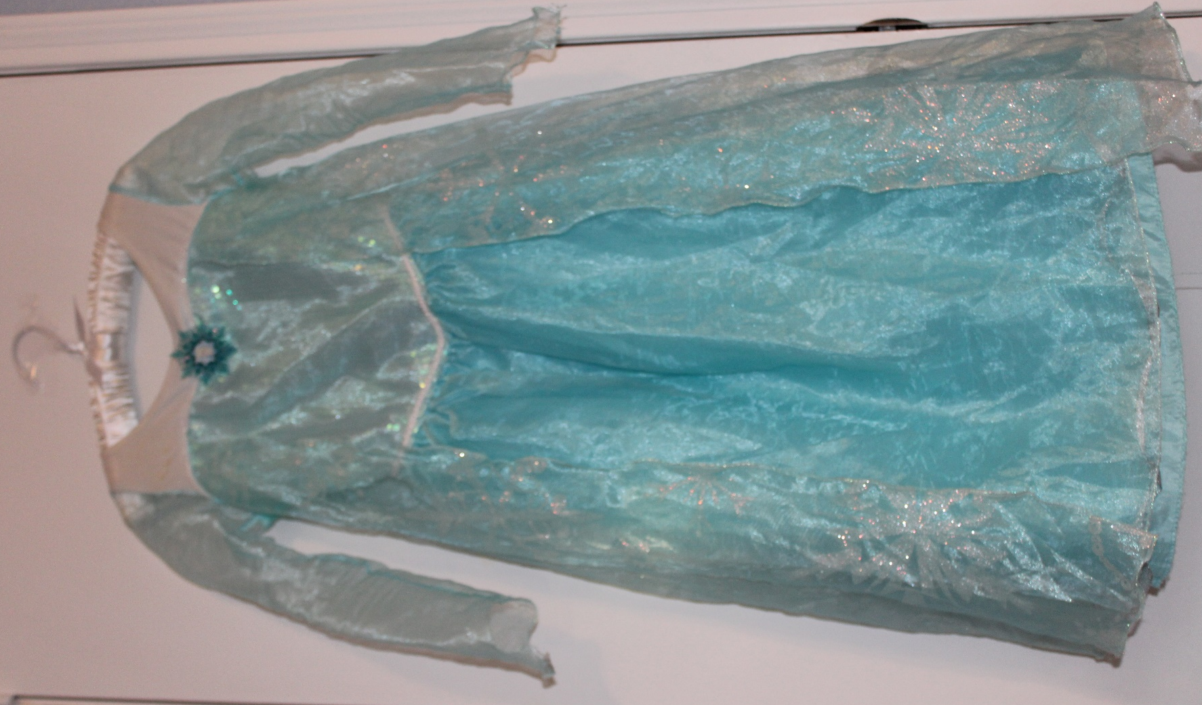
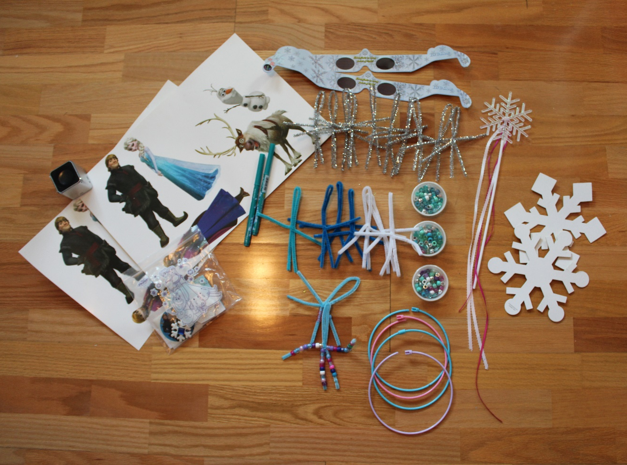

Pottery Barn MONARCH BUTTERFLY Tutu Costume – Size 7/8 – Excellent condition ($25)
Monarch Butterfly Tutu costume bought at Pottery Barn – EXCELLENT CONDITION
Your little one will love wearing this appliquéd tulle skirt, lavish organza wings and beautiful butterfly crown.

- Three-piece design includes dress, wings and headband.
- Made of nylon tulle and polyester jersey.
- Detailed with tulle tutu above skirt.
- Undergarments not included.
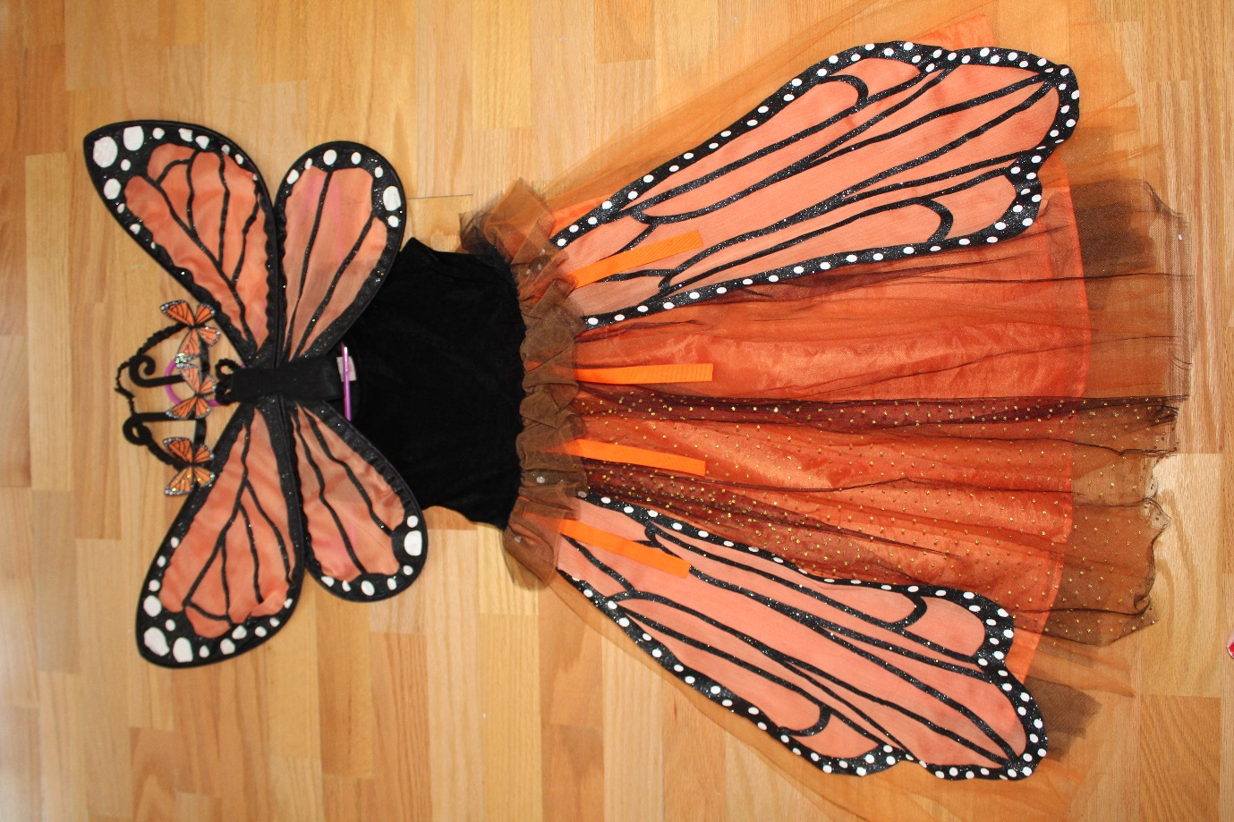

NINJA Deluxe Costume with Ninja throwing stars and 2 daggers – size 5/6 – Excellent condition ($15)
NINJA Deluxe Costume with Ninja 2 daggers and 3 throwing stars – EXCELLENT CONDITION
- includes Jumpsuit with Attached Hood, Face Mask, Belt, 3 Throwing Stars and 2 Ninja Daggers!!!
- Ninja Costume Kids Deluxe Costume Set. Super Durable. Superior Quality.
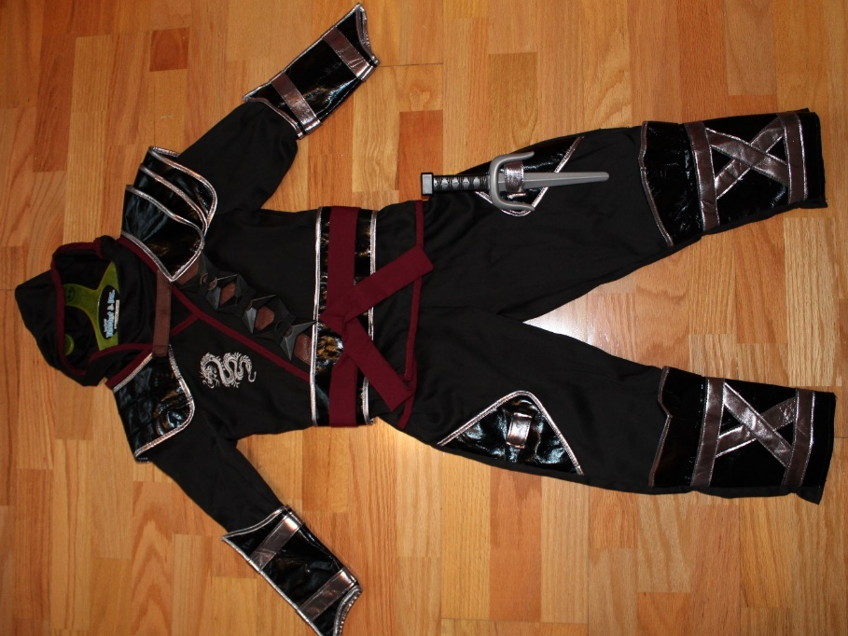

Package of 2 toddler costumes: Batman costume with CAPE and mask & Fireman jacket with Helmet and bullhorn – size 4/5 – Excellent condition ($20 both)

- BATMAN Costume with abs Muscles, cape and mask
- includes Jumpsuit with abs Muscles, Face Mask attached to the cape, and a Belt
- Size: 4/5 years old

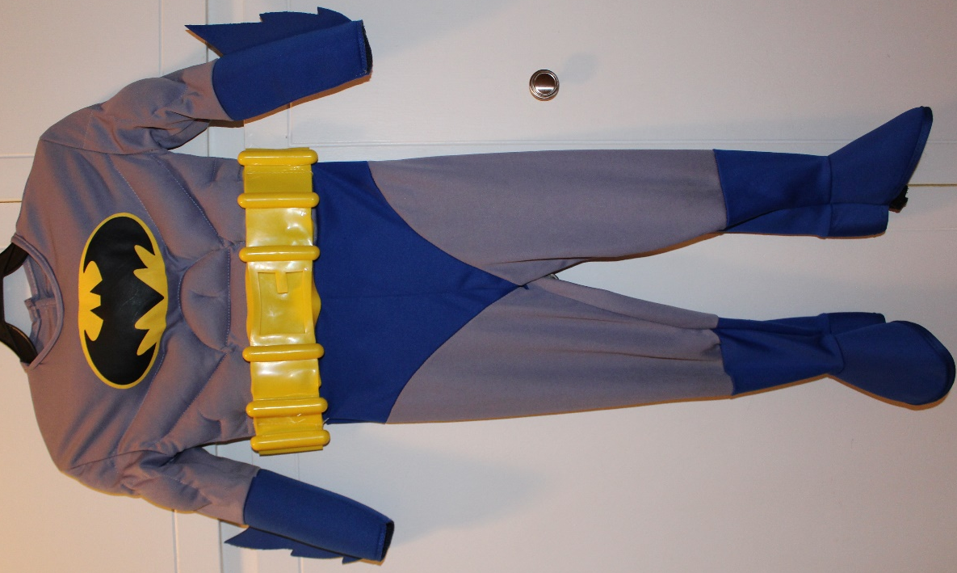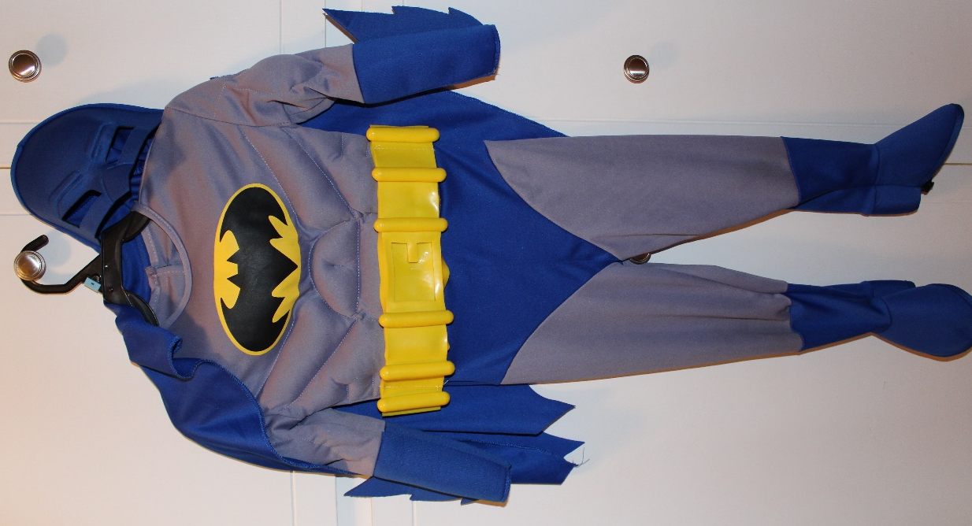

- Melissa & Doug Fire Chief Role Play Costume Dress-Up Set Costume
- Dress-up-and-play set with everything a child needs to look the Part, plus exciting accessories to Spur imaginative play
- Includes jacket, helmet, badge, bullhorn and reusable name tag.
- Bullhorn makes sound effects (batteries included)!
- High-quality materials ensure durability and safety.

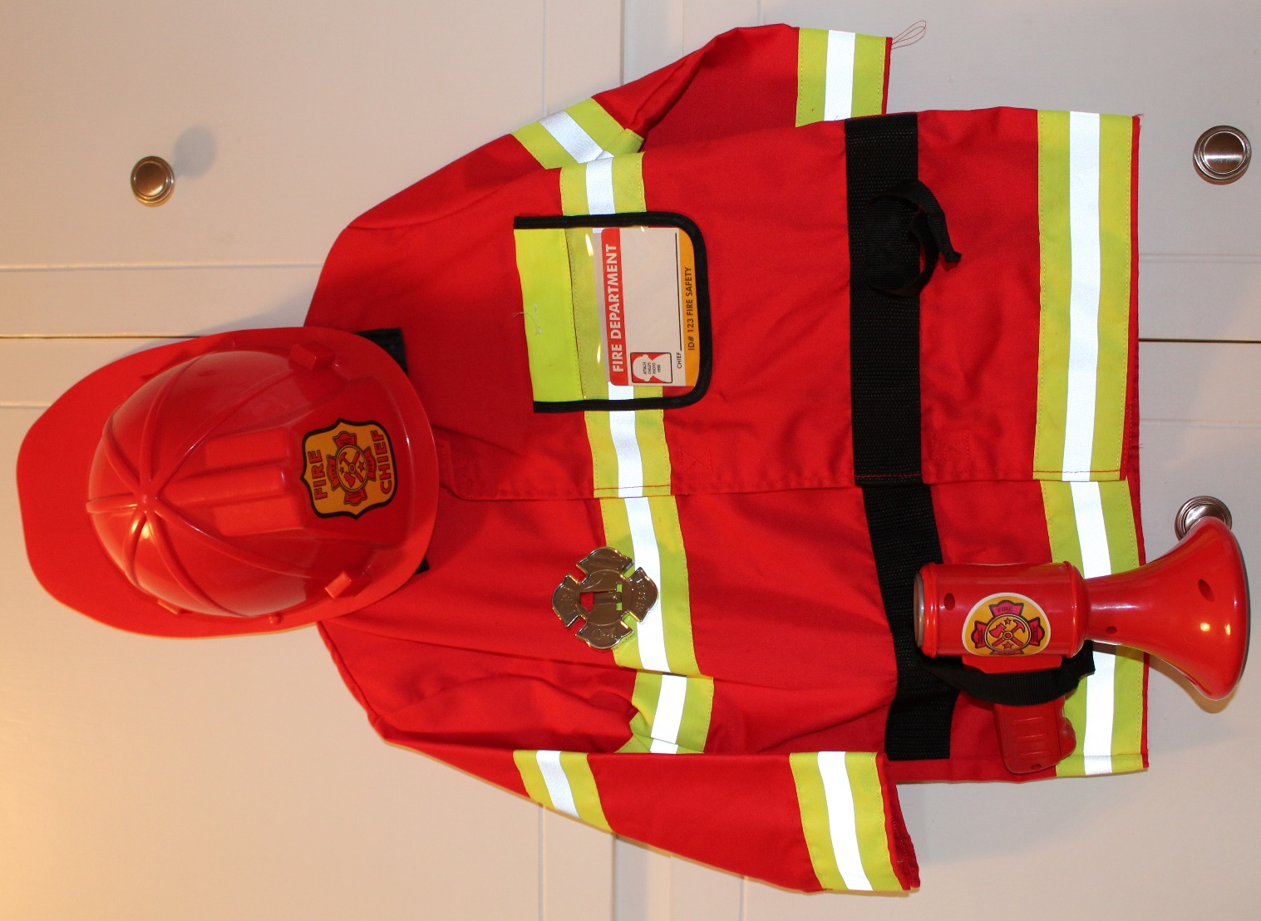

Red Turbo racer toddler costume – size 3/4 – excellent condition ($10)
Red Turbo racer toddler costume – size 3/4 – excellent condition
- vinyl
- Fun, Colorful, Inventive designs to put you in the world of role play
- Whether it's Halloween, birthday parties, or even a fun filled night, disguise is good for everything!
- Helmet

