For sale (relocating to Europe)
BMW 328i sedan, very good condition - $13,500
Model 2013 - 45,000 miles

- Grey exterior
- Leather seats (black)
- Open roof
- 240 HP, 8 gears steptronic
- Electric front seats, electric all 4 windows
- Foldable back seats (60/40)
- Cruise control
- Business GPS
- Head-up display
- Driver helps: blind spot with haptic feedback, helicopter view etc
- Heated front seats
- Remote access, keyless start/stop
- Clean Carfax report

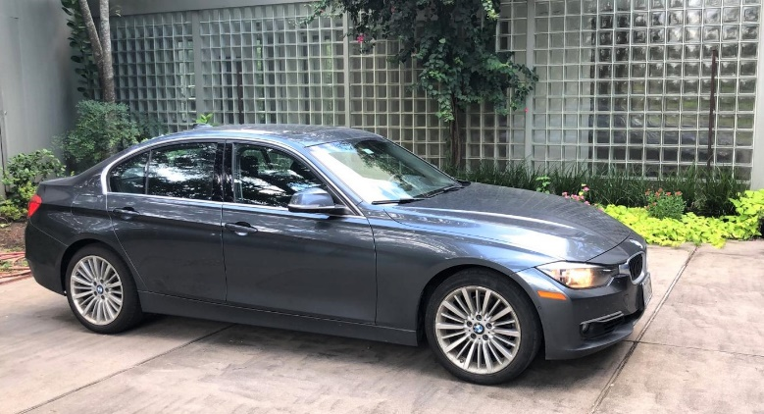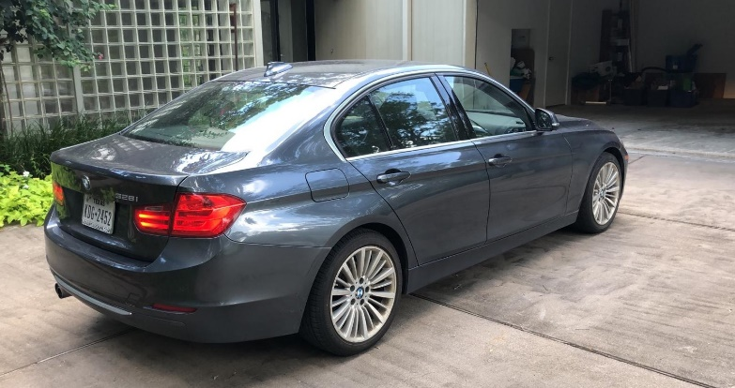

Price: $13,500
Pls. leave a voicemail or an email to Michel Muylle at:
+ 1 832 331-1020
muyllemichel@gmail.com

