FURNITURE (tables, chairs, bedroom furniture, sofa, etc…)

AVAILABLE LATE JUNE

1 | Tempered glass dinning table with 4 chairs and 4 red removable cushions  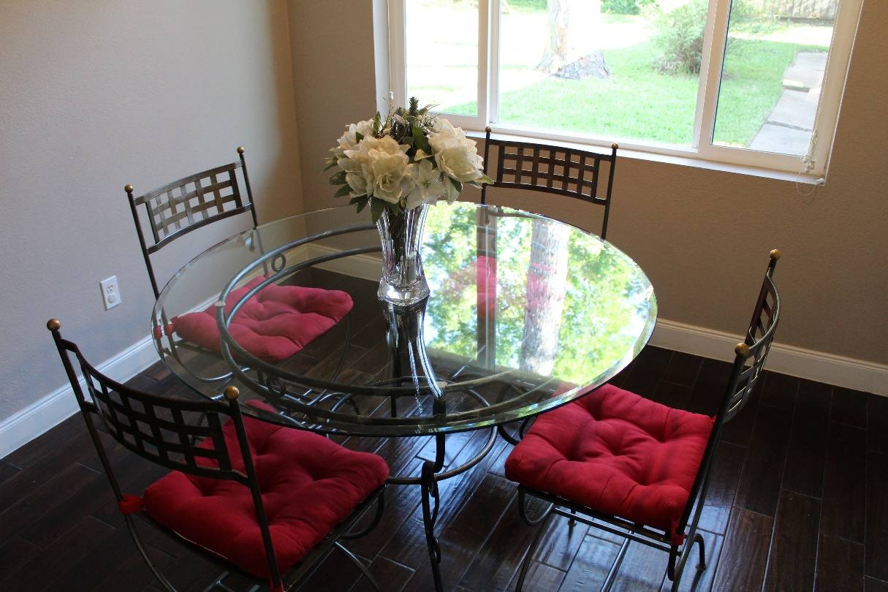 | $150
2 | Convertible sofa (2 seats and 5 back cushions) - INTERIORS | $150
3 | 2 White Bar stools with backrest frame - IKEA | $30
4 | Table Lamp and shade – AT HOME | $20
5 | Artificial Potted Plant - Weeping fig, 8 ¼ - IKEA | $20
6 | 2 Nightstands – without the bedside lamps - IKEA | $20
7 | Bedside truck lamp – ROOMS TO GO | $20
8 | Elliott Nightstand charcoal – POTTERY BARN FOR KIDS | $45
9 | Painting (3F4 / 3F4) – AT HOME | $20
10 | Painting (3F / 1F) – AT HOME | $10
11 | 2 Bedside lamps - TARGET | $20
12 | 1 Bedside / Desk Lamp – IKEA | $15
13 | 1 Table Lamp with pink shade – POTTERY BARN FOR KIDS | $20
14 | Madras Blackout Curtains - POTTERY BARN (excellent condition) | $30
15 | Evelyn Linen Blend Ruffle Bottom Blackout Curtain Panel - POTTERY BARN (excellent condition) | $30

